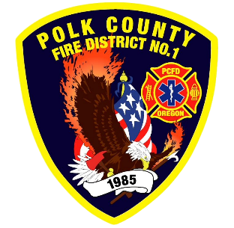
Training and Operations Report
Deputy Chief Training/Operations Neal Olson
September 2026
June Events
Training, Public Education Events, Special Events
- 8/5 Officer and P1FFA Meeting
- 8/7 Summer Series - Music in the Park
- 8/12 Drill - Ropes/Haul System and Command and Control for new Engineers
- 8/13 Board of Directors Meeting
- 8/14 Summer Series - Music in the Park
- 8/19 Drill - Ground Ladders Part 1
- 8/22 EAA Fly-In at Independence Airport
- 8/24 EMS Drill
- 8/26 Drill - Ground Ladders Part 2

Upcoming Events
- 9/2 Officer and P1FFA Meeting
- 9/3 SCBA Testing 9/3 and 4
- 9/7 Labor Day Holiday - Office Closed
- 9/8 WVCC Fire Services Meeting
- 9/9 Drill - START Triage, Forcible Entry with Falls City Fire
- 9/10 Board of Directors Meeting
- 9/16 Drill - Regional MCI Plan
- 9/19 Talmadge Rd. Cleanup
- 9/21 EMS Drill
- 9/23 Drill - MCI Resources
- 9/24 Operational Meeting with Staff Captains
- 9/24 Hose Testing 9/24 and 25
- 9/26 Fall Fire School at DPSST 9/26 and 27
- 9/26 Independence Hop and Heritage Festival
- 9/26 WOU Football vs. Angelo State Standby
- 9/30 Drill - Multi-Company MCI Drill

Informational Items
- 327 Incidents last month.
- 452 Hours of Training and Continuing Education last month.
- 6 Certification(s) received last month
  - Austin Champ: Passenger Vehicle Rescue Operations and Technician
  - Corban Ibarra: Firefighter I, HazMat Awareness and Operations
  - Maxwell Patel: Wildland Firefighter Type 1

Training Calendar
