Training and Operations Division Report
Polk County
Fire District No.1

October Report for the month of September 2025
Deputy Chief – Neal Olson

This Month’s Events (i.e. Training, Public Education Events, Special Events)
- 9/1 Labor Day Holiday - Office Closed
- 9/3 Officer and P1FFA Meetings
- 9/5 CHS Football Standby
- 9/6 WOU Football Standby
- 9/6 EE Wilson Live Fire Operations with Adair Fire and ODF
- 9/10 Drill - START Triage
- 9/11 Board of Directors Meeting
- 9/15 Albany Fire will be training in our drill tower Monday-Thursday
- 9/17 Drill - MCI Resources
- 9/20 WOU Football Standby
- 9/23 PALS Training
- 9/24 Drill - MCI Drill: Multi-Company Evolution
- 9/26 CHS Football Standby

Upcoming Events (i.e. Training, Public Education Events, Special Events)
- 10/1 Blood Drive at Sta. 90
- 10/1 Olson teaching EMD at DPSST
- 10/1 Officer Meeting and P1FFA Meetings
- 10/4 EMS Standby at WOU Football
- 10/8 Drill - Vehicle Stabilization
- 10/9 Board of Directors Meeting
- 10/10 EMS Standby at CHS Football
- 10/11 Extrication Day
- 10/14 Holiday - Be Bald and Be Free Day
- 10/15 Drill - Extrication Tools
- 10/18 EMS Standby at WOU Football
- 10/22 Drill - Vehicle Extrication
- 10/23 ACLS Class at Sta. 90
- 10/26 National First Responders Day
- 10/28 OSHA Inspection
- 10/29 Drill - Extrication Multi-Company Drill
- 10/31 EMS Standby at CHS Football
- 11/1 EMS Standby at WOU Football

Informational Items –
- 321 Incidents last month.
- 530 Hours of Training and Continuing Education last month.
- 4 Certification(s) received last month
  - Harmony Alvarez - Firefighter Type 1
  - Stephen Hoem - Instructor 2
  - Doug Stewart - Wildland Fire Apparatus Operator and Mobile Water Supply Apparatus Operator

Training Calendar
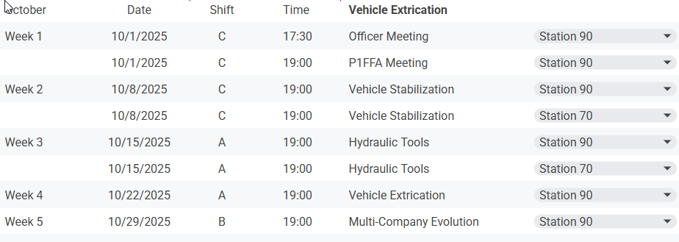

Respectfully Submitted
Neal Olson

