Training and Operations Division Report
Polk County
Fire District No.1

November Report for the month of October 2025
Deputy Chief – Neal Olson

This Month’s Events (i.e. Training, Public Education Events, Special Events)
- 10/1 Blood Drive at Sta. 90
- 10/1 Olson teaching EMD at DPSST
- 10/1 Officer Meeting and P1FFA Meetings
- 10/4 EMS Standby at WOU Football
- 10/8 Drill - Vehicle Stabilization
- 10/9 Board of Directors Meeting
- 10/10 EMS Standby at CHS Football
- 10/11 Extrication Day
- 10/14 Holiday - Be Bald and Be Free Day
- 10/15 Drill - Extrication Tools
- 10/18 EMS Standby at WOU Football
- 10/22 Drill - Vehicle Extrication
- 10/23 ACLS Class at Sta. 90
- 10/26 National First Responders Day
- 10/28 OSHA Inspection
- 10/29 Drill - Extrication Multi-Company Drill
- 10/31 EMS Standby at CHS Football
- 11/1 EMS Standby at WOU Football

Upcoming Events (i.e. Training, Public Education Events, Special Events)
- 11/1 WOU Football Standby
- 11/5 Officer and P1FFA Meetings
- 11/6 Salem Fire Accreditation Review
- 11/10 Drakes Crossing Accreditation Review
- 11/10 Board of Directors Meeting
- 11/10 Marine Corps Birthday - Ooh Rah!
- 11/11 Veteran’s Day Holiday - Office Closed
- 11/12 Drill - Firefighter Skills and FIT Testing
- 11/15 WOU Football Standby
- 11/19 Drill - Firefighter Skills and FIT Testing
- 11/24 EMS Drill
- 11/27 Thanksgiving Day Holiday - Office Closed
- 11/28 Holiday - Office Closed

Informational Items –
- 329 Incidents last month.
- 689.5 Hours of Training and Continuing Education last month.
- 6 Certification(s) received last month
  - Dakota Allen: Wildland Firefighter Type 2
  - Travis Emerling: Aerial Operator and Wildland Firefighter Type 2
  - Allana Russell: HazMat Awareness, Operations and Firefighter I

Training Calendar
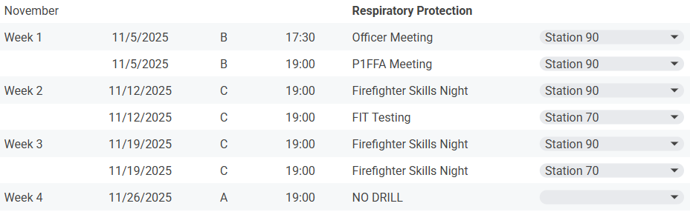

Respectfully Submitted
Neal Olson

