

September 2025 Report for the month of August 2025

Deputy Chief – Neal Olson

**This Month’s Events** (i.e. Training, Public Education Events, Special Events)

* 8/6 Officer and P1FFA Meetings
* 8/13 Drill: Straight Ladders - Carries and Raises, Engineer Academy
* 8/13 Olson at DPSST for EMD Course, W, Th, F
* 8/14 Board of Directors Meeting
* 8/20 Drill: Extension Ladders - Carries and Raises, Engineer Academy
* 8/25 EMS Drill
* 8/27 Drill: Working from ladders, hoselines and rescues, Engineer Academy

**Upcoming Events** (i.e. Training, Public Education Events, Special Events)

* 9/1 Labor Day Holiday - Office Closed
* 9/3 Officer and P1FFA Meetings
* 9/5 CHS Football Standby
* 9/6 WOU Football Standby
* 9/6 EE Wilson Live Fire Operations with Adair Fire and ODF
* 9/10 Drill - START Triage
* 9/11 Board of Directors Meeting
* 9/15 Albany Fire will be training in our drill tower Monday-Thursday
* 9/17 Drill - MCI Resources
* 9/20 WOU Football Standby
* 9/23 PALS Training
* 9/24 Drill - MCI Drill: Multi-Company Evolution
* 9/26 CHS Football Standby

**Informational Items –**

* 342 Incidents last month.
* 556 Hours of Training and Continuing Education last month.
* 13 Certification(s) received last month
  + Champ - HazMat IC
  + Connerly, S - Firefighter 1, Driver, WFAO
  + Graham, DJ - HazMat Awareness and Operations
  + Hoem, S - Fire Officer 1 and Live Fire Instructor
  + Rose, A - Fire Officer 1
  + Schilz, A - Fire Officer 1
  + Walters, B - ENGB, Instructor 2 and Live Fire Instructor

Training Calendar

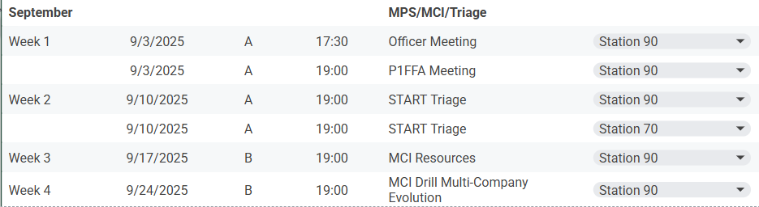

*Respectfully Submitted*

***Neal Olson***