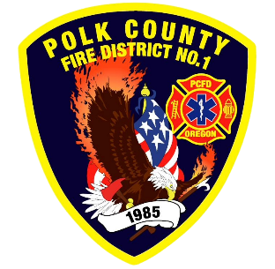
EMS and Logistic Report
Division Chief of EMS/Logistics Frank Ehrmantraut
August 2026

July Highlights
- Independence Days – This year the District partnered with Polk County Public Health to provide first aid and emergency response services to the festival. Public Health set up their immunization/clinic trailer to provide us with an air conditioned, private area for first aid treatment and nursing mothers.
- EMS Training Coordinator – Our grant funded EMS training coordinator is fully functioning. She is in the process of evaluating equipment, coordinating with instructors, and scheduling classes for our agency, as well as local partners.
- STEMI Feedback Session – Our District participates in Salem Health’s quality assurance program for STEMI activations. In addition to actionable feedback, a local cardiologist provides continuing education for our EMS providers.
- Rural Health Transformation Program – There has been several meetings and actions taken to prepare for the process of standing up a regional community paramedic program. This program will cross jurisdictional boundaries and work with Polk County Family Community Outreach to pair resource navigators with the Community Paramedics.
- Marion County ASA – We had our quarterly meeting with Marion County to ensure compliance with the response requirements that they have set. The ASA Administrator for Marion County is now Troy Gregg. He has been with Marion County for several years in leadership roles. Although he is new to EMS, he seems like a good fit for the role.
- EMS Committee – The District’s EMS Committee is meeting monthly to give a formal forum for line staff to communicate their needs and solutions regarding EMS delivery in our District.
Apparatus Updates
- 464 - Lube, Oil, and Filters
- 461 - Pump Panel Light Fixed
- 481 - Hose Reel Repaired, Post Conflagration Inspection
- 469 - Fuel System Cleaned, IPR Replaced, Siren Evaluated
- 461 - Officer Window and Tank Repaired, Air Compressor and Pump Light Replaced
- 486 - Work to prepare new ambulance

