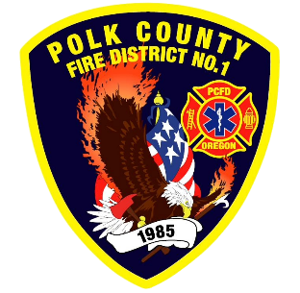
EMS and Logistic Report
Division Chief of EMS/Logistics Frank Ehrmantraut
June 2026

May Highlights
- New Employee Orientation – During the orientation of Probationary FF/Paramedic Alvarez, she spent about 15 hours working reviewing EMS protocols, high risk/low frequency skills, EMS SOGS, and equipment orientation.
- Data Partnership – The Confederated Tribes of Grand Ronde, Dallas Fire & EMS, Southwest Polk Rural Fire Protection District, and Sheridan Fire District have agreed to share data to better identify super users in our County. This data contributes to the work done by Willamette Health Council’s Mobile Health Services Workgroup, of which, Polk County Fire District was invited to be a member.
- Rural Health Transformation Grant – Several meetings were had in May with multiple stakeholders regarding the creation of a Polk County Community Paramedic Coalition to serve members of rural Polk County. A Federal grant opportunity, passed through the state, would be used to fund this program for two years, with the possibility of sustained funding beyond two years.
- Regional Midwife’s Association – Chief Ehrmantraut was asked to present to the regional group of the Oregon Midwife’s Association. They have agreed to provide training to our EMS providers to strengthen the relationship and understanding between our two professions.
- Resident Volunteer Interviews – We had seven students apply for two open resident volunteer positions. The interviews were very competitive. We are pleased to offer positions to Lane Cole (a current volunteer) and Carter Howard (a graduate of West Salem High Schools CET program) who are both working towards an AAS Paramedicine Degree.
- Chemeketa Paramedic Program Interviews – The District participated in the interview process for the upcoming paramedic class at Chemeketa. The program had 103 applicants which narrowed to 73 interviews for 24 spots.

Apparatus Updates
- B459 – The wildland pump on this apparatus needed to be rebuilt after a catastrophic failure.
- E93 – Weather stripping was repaired on rear compartments; battery switch was repaired.
- M474 – Brakes inspected
- M477 – Lights replaced
- Bikes – The bikes were serviced and repaired in preparation for the 4th of July parade and other events in which bike medics are used.

