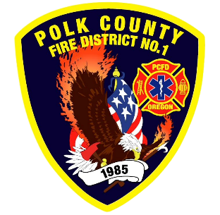
EMS and Logistic Report
Division Chief of EMS/Logistics Frank Ehrmantraut
September 2026

August Highlights
- Rural Health Transformation Program – There continues to be several meetings and actions taken to prepare for the process of standing up a regional community paramedic program. The current obstacle is budget approval due to the funding mechanism of the grant. This program will cross jurisdictional boundaries and work with Polk County Family Community Outreach to pair resource navigators with the Community Paramedics.
- Oregon EMS Advisory Committee – This group, of which Chief Ehrmantraut is an appointed member, makes recommendations to the EMS Advisory board regarding ambulance agencies and providers.
- EMS Committee – The District’s EMS Committee is meeting monthly to give a formal forum for line staff to communicate their needs and solutions regarding EMS delivery in our District.
Apparatus Updates
- T481 - Power strip inside cab evaluated. Discovered that they do not work unless the apparatus is plugged in. Hose reel bar repaired. Post deployment inspection.
- B459 - Booster reel evaluated for low flow.
- S481 - Lube, oil, and filter
- E473 - Radio power strip repaired
- D464 - Emergency light on the canopy was re-attached.
- M486 - A variety of work was completed to get the new ambulance into service.
- E471 - It was reported that pump and roll were not functioning.
- E469 - Tires evaluated and appropriate replacements/changes were made. Headlights replaced with LEDs after one burned out.
- S460 - Lube, oil, and filter. Windows tinted.
- T465 - Driver’s seat reported to be leaking air. DEF topped off.
- M477 - Lube, oil, and filter. Shore line charger replaced.

