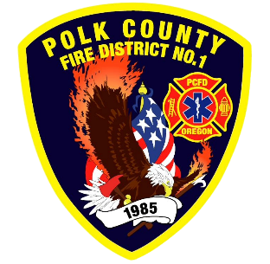
Training and Operations Report
Deputy Chief Training/Operations Neal Olson
June 2026
May Events
Training, Public Education Events, Special Events
- 5/2 OSFM Engine Boss Forum
- 5/6 Officer and P1FFA Meeting, Academy: Fire Service Tools
- 5/9 Recruit Academy: Forcible Entry and Vehicle Fires
- 5/11 Fire Services Meeting at WVCC
- 5/13 Wildland Refresher Training and Engineer Academy
- 5/18 Fire District Budget Meeting
- 5/20 Capitol Region Operations Meeting at Salem Fire
- 5/20 Wildland Refresher Training and Engineer Academy
- 5/25 Memorial Day Holiday, Office closed
- 5/27 Wildland Refresher Training and Engineer Academy
- 5/30 Recruit Academy: Tactical Ventilation

Upcoming Events
- 6/3 Officer and P1FFA Meeting
- 6/5 Metro Area Wildfire School
- 6/5 Central High School Graduation Ceremony Standby
- 6/6 Metro Area Wildfire School
- 6/9 Olson at DPSST for EMD class 6/9, 10
- 6/10 Drill - Conflagration Pre-Season Review, Confined Space and Gas Monitors
- 6/13 WOU Commencement Standby
- 6/13 S-131 Wildland Firefighter Type I in Silverton
- 6/16 Training Meeting with MCFD#1 Training Officer
- 6/17 Operational Peer Support Symposium at DPSST
- 6/17 Drill - Structural Search Tactics
- 6/19 Juneteenth Holiday - Office Closed
- 6/14 Drill - Multi-Company Evolutions
- 6/27 Live Fire Training at Adair Rural with Mobile Fire Training Unit

Informational Items
- 301 Incidents last month.
- 870 Hours of Training and Continuing Education last month.

- 2 Certification(s) received last month
  - Brenden Shellito: Fire & Life Safety Educator II
  - Neal Olson: Fire & Life Safety Educator II

Training Calendar
