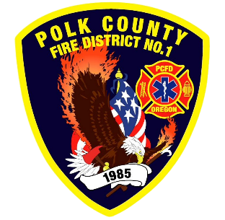
Fire Prevention Report
Division Chief Fire Marshal Troy Crafton
September 2026

August Events
Plan Review, Inspections, Training, Incident Response
- Qdoba Final Inspection
- 75 C St Inspection
- 291 Pacific Hwy Inspection
- Daycare License Inspection
- OSHA Inspection
- Wildfire Mitigation
- OSFM Defensible Space Assessor Training
- 1 - Food Truck Inspections
- 1 - Complaints
- 1 - Driveway inspections
- 9 - Business Inspection
- 20 - Plan Review Projects
- 3 - Smoke Alarm Installs
- 1- Knox Boxes
- Flow MSP set up and Pre-Plans
- Risk Reduction Grant for District Addressing / Preplanning / Wildfire Mitigation
- 7.5 Hours Fire Marshal Service IGA Dallas Fire Department
- 0 Hours Fire Marshal Service IGA Polk County Building Department
- 6 Incident With 5.5 Hours of Response
Upcoming Events
- MICC Meeting
- Safety Committee Meeting
- Officer Meeting
- Willamette Valley Wildfire Coalition
- Youth with Fire Workshop
- Monmouth City Project Meeting
- Independence City Project Meeting
- Monmouth Building Meeting Every Thursday
- Dallas DRT Meeting Every Thursday
Activities
- 3 - PRE-APP Independence
- 3 - PRE-APP Monmouth
- Willamette Valley Wildfire Coalition
- Youth with Fire Workshop
- OLST Meeting
- MBA Meeting
- MICC Meeting
- MPFIT Meeting
- Safety Committee Meeting
- Officer Meeting
- Monmouth City Project Meeting
- Independence City Project Meeting
- Monmouth Building Meeting Every Thursday
- Dallas DRT Meeting Every Thursday

